Park Street Manufacturing

# Software Design Template

Version 1.0

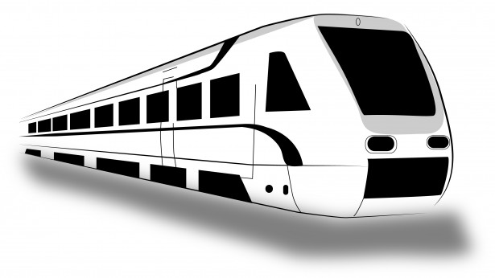

## Table of Contents

Software Design Template 1

Table of Contents 2

Document Revision History 2

Executive Summary 3

Requirements 3

Design Constraints 3

Rationale 3

## Document Revision History

| Version | Date | Author | Comments |
| --- | --- | --- | --- |
| 1.0 | 09/23/2023 | David Greene | Updated executive Summary, constraints |

## Executive Summary

Park Station Manufacturing, a manufacturing company currently using Windows exclusively, wants to produce high-quality video clips for training and educational purposes. They require video editing software that is only available for Mac, as Macs are known for their superior desktop publishing capabilities. The challenge lies in finding a solution that allows the company to use Mac-exclusive software on their Windows-based systems.

## Requirements

**Business Requirements:**

1. Produce video clips for training and educational purposes.
2. Use high-quality video editing software.
3. Utilize software with superior desktop publishing capabilities.

**Technical Requirements:**

1. Use video editing software that is only available for Mac.
2. Run Mac-exclusive software on Windows-based systems.
3. Ensure hardware is capable of handling resource-intensive video editing tasks.
4. Consider any specific hardware requirements of the Mac-exclusive software.
5. Address the need for training and skill development for employees unfamiliar with Mac software.

## Design Constraints

1. Compatibility Constraint: The client's requirement to use Mac-exclusive video editing software poses a compatibility constraint. As the company currently uses Windows, they need a solution that allows them to run Mac software on their Windows-based systems. This constraint affects the choice of software and may require the use of virtualization or emulation technologies to enable Mac software functionality on Windows.
2. Hardware Constraint: The client's desire for high-quality video editing necessitates hardware capable of handling resource-intensive tasks. This constraint may require the company to upgrade their existing hardware, such as graphics cards, processors, and memory, to meet the demands of the video editing software. Additionally, Mac-exclusive software may have specific hardware requirements that need to be considered.
3. Training and Skill Constraint: The client's employees are currently familiar with Windows-based systems, and introducing Mac-exclusive software may require additional training and skill development. This constraint affects the company's business processes and may require allocating resources for training programs or hiring individuals with Mac expertise.

## Rationale

1. Compatibility Constraint: The client's requirement to use Mac-exclusive software on Windows systems creates a design constraint as it limits the available software options. This constraint is both a technical and business constraint since it affects the software choices and the company's ability to achieve their desired video editing capabilities.
2. Hardware Constraint: The need for high-quality video editing imposes a hardware constraint as the existing hardware may not meet the software's requirements. This constraint is primarily technical, as it relates to the hardware capabilities needed to handle resource-intensive tasks efficiently.
3. Training and Skill Constraint: The client's employees' familiarity with Windows-based systems and lack of experience with Mac software creates a training and skill constraint. This constraint is both a technical and business constraint since it affects the company's ability to effectively use the chosen software and may require additional resources for training or hiring.
4. By identifying and addressing these design constraints, we can develop a solution that allows Park Station Manufacturing to produce high-quality video clips using Mac-exclusive software on their Windows-based systems.